**Shipping Data Dashboards**

1. Dashboard Tutorial from Tableau Help

A dashboard is a collection of several worksheets and supporting information shown in a single place so you can compare and monitor a variety of data simultaneously. For example, you may have a set of views that you review every day. Rather than flipping through each worksheet, you can create a dashboard that displays all the views at once.

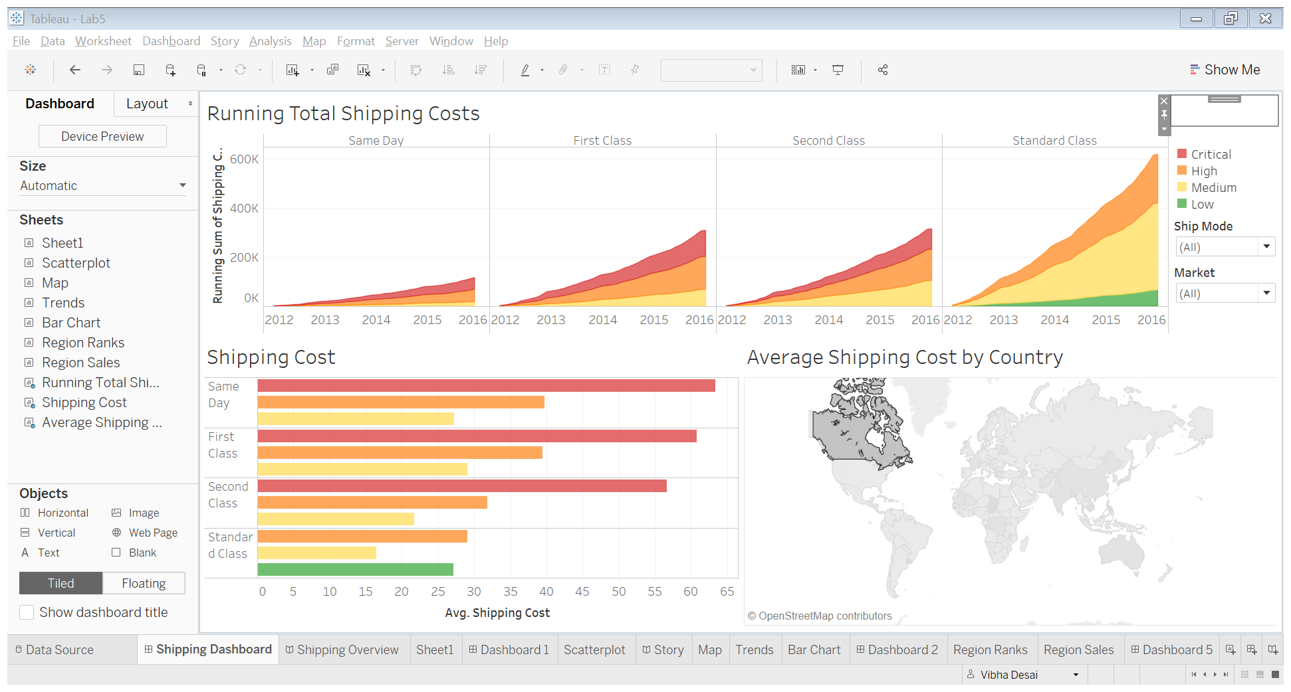

Figure 1: Shipping Dashboard

A well-designed dashboard can align your organization's efforts, help uncover key insights, and speed up decision-making. To create a dashboard:

* Know your purpose and audience
* Leverage the most-viewed spot
* Design for the real world
* Limit the number of views
* Be security-savvy
* Add interactivity to encourage exploration
* Enable highlighting

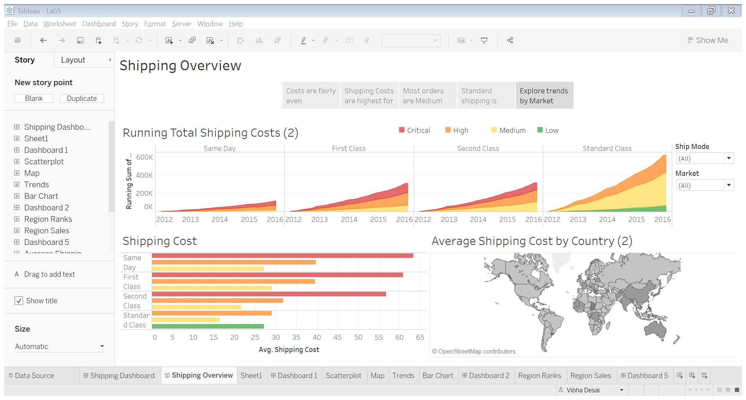

Figure 2: Shipping Overview Dashboard

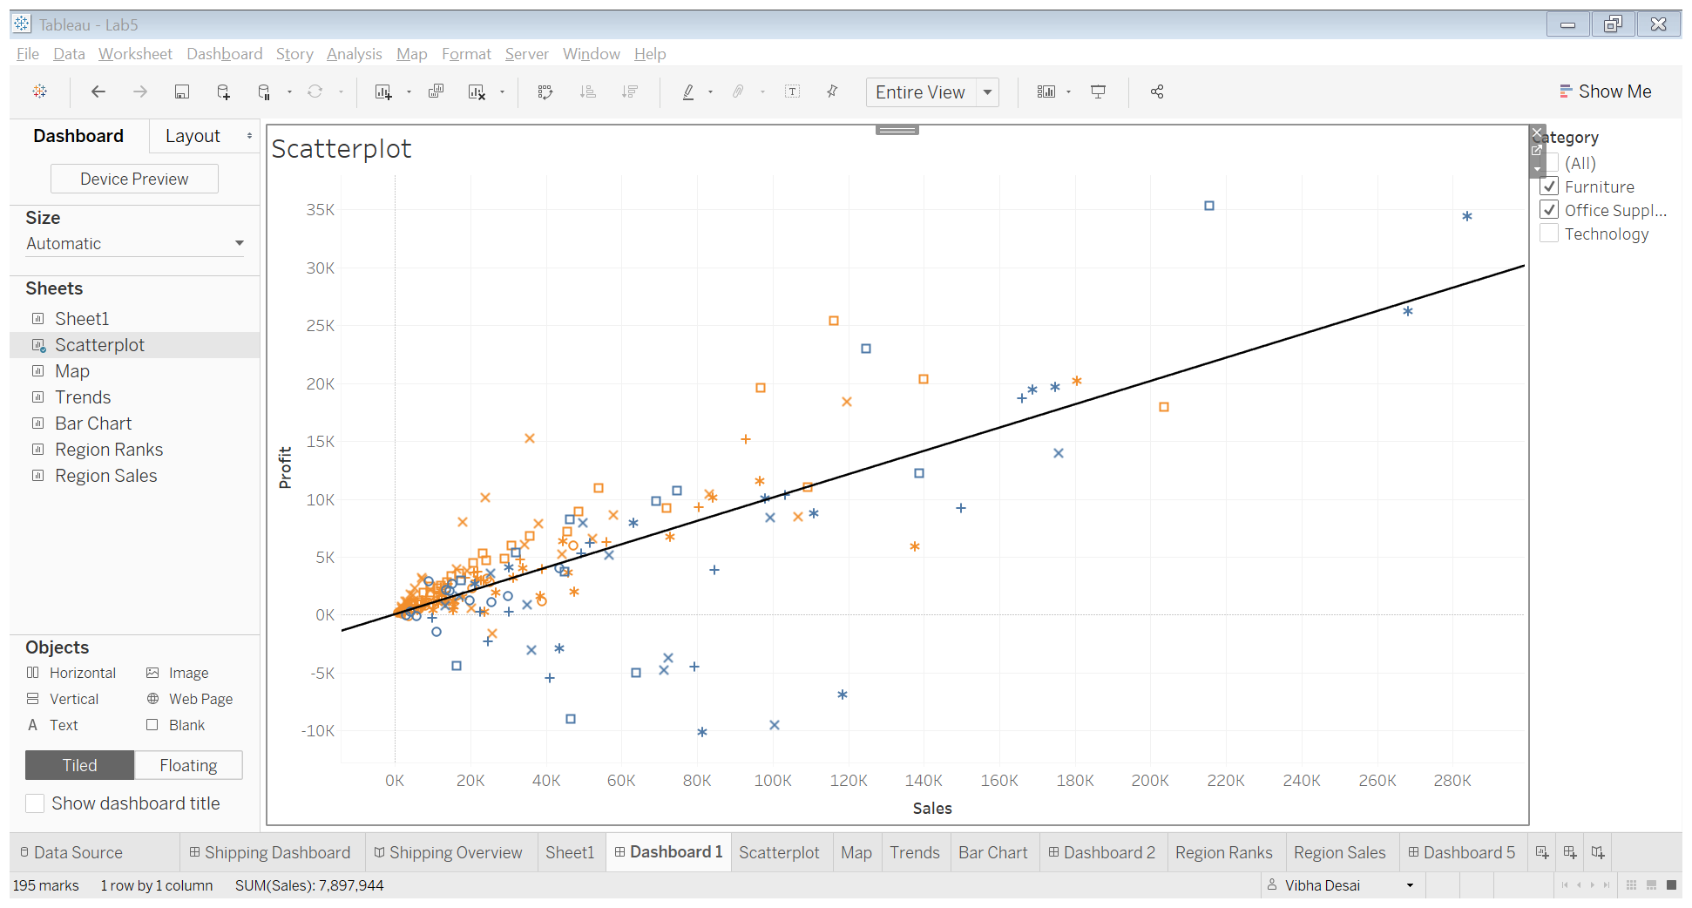

Figure 3: Scatter Plot Dashboard

1. Recreate a dashboard for the superstore data

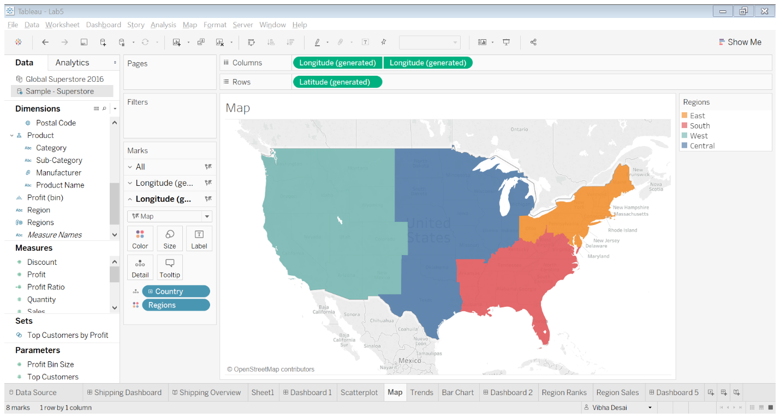

Figure 4: Creating map view

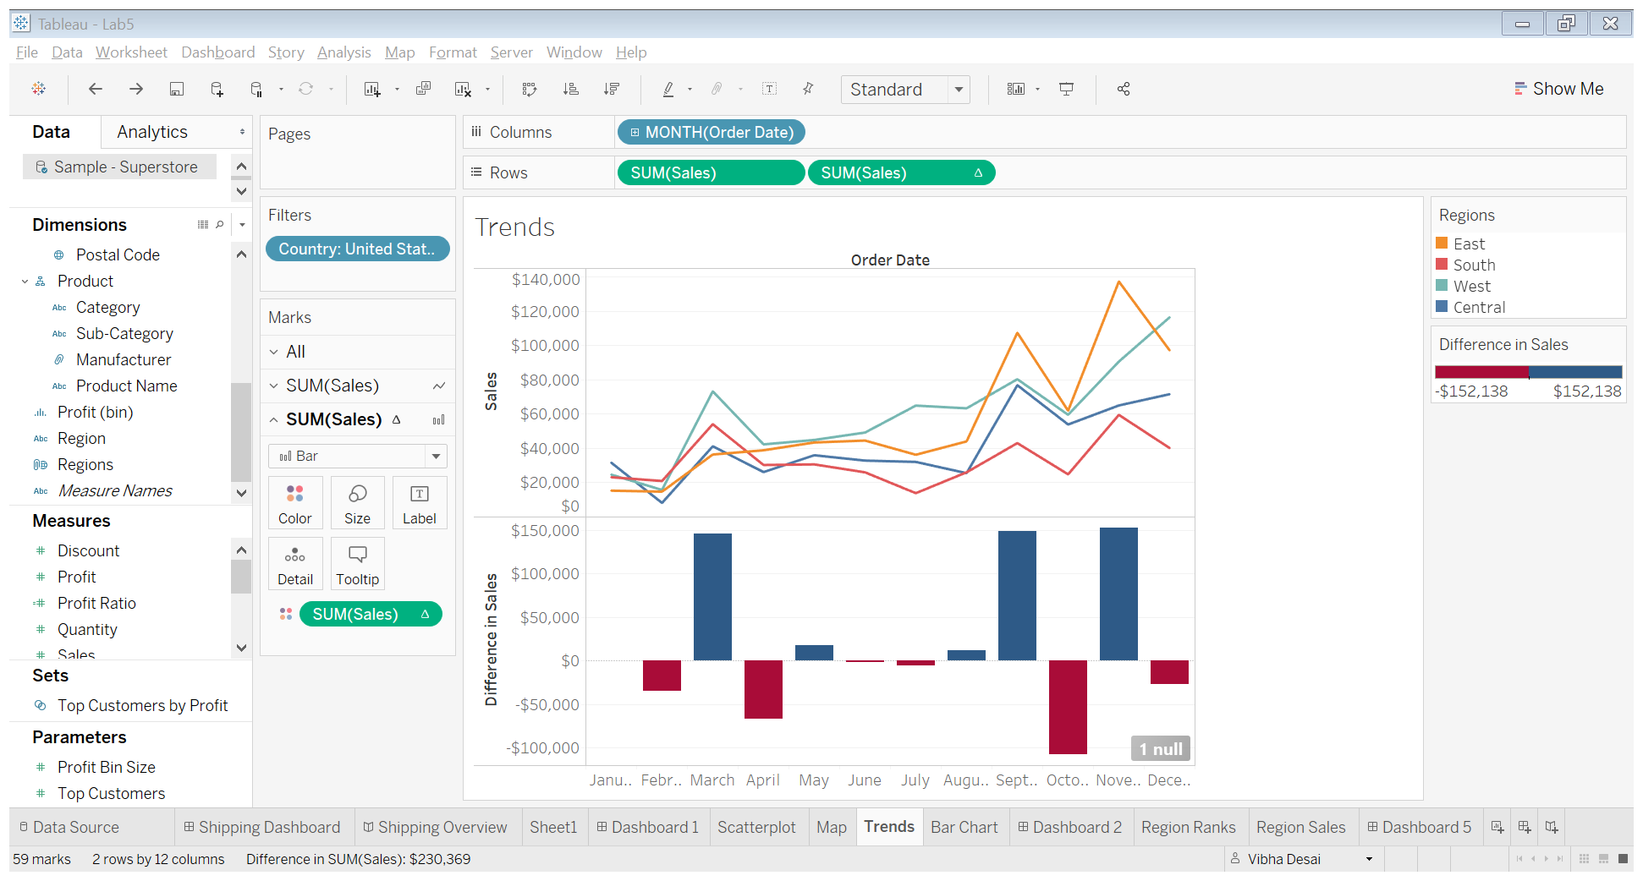

Figure 5: Creating Trends view

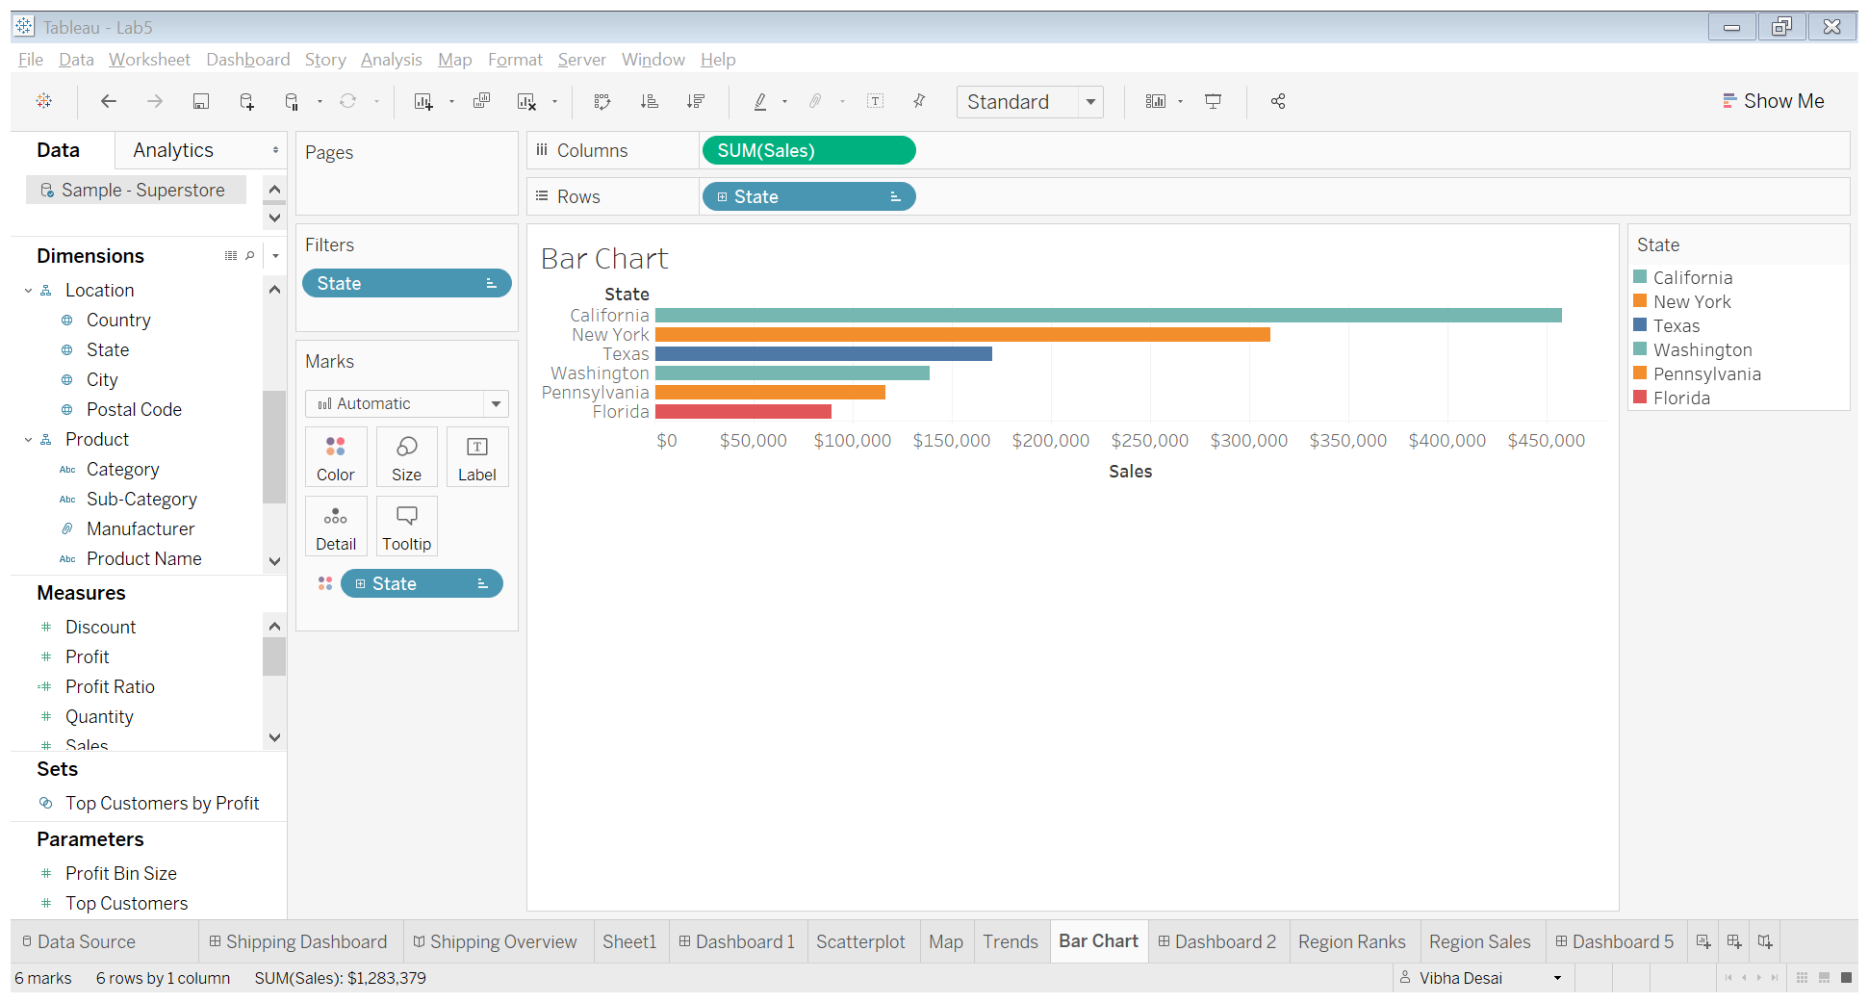

Figure 6: Creating bar chart

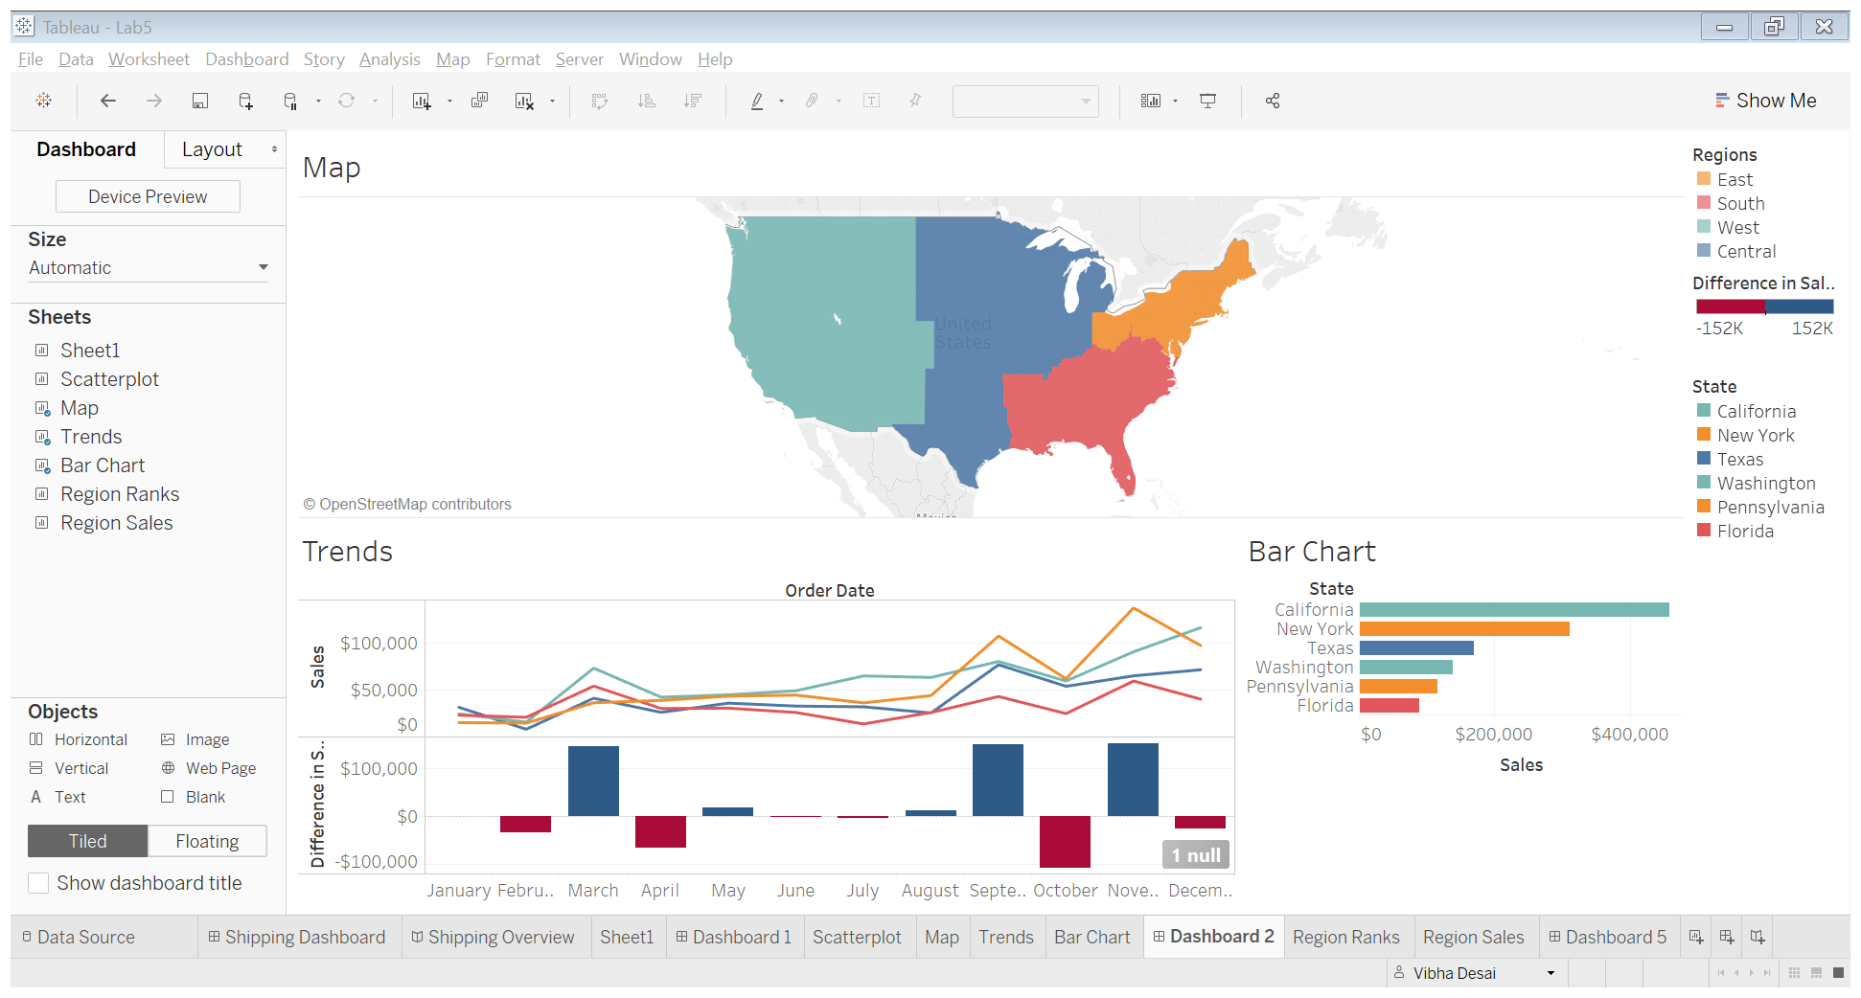

Figure 7: Recreating Ryan Sleeper’s Dashboard

The dashboard created by Ryan Sleeper is highlighting Superstore data. The map highlights the Sales in each region of the United States. I was unable to show the bubble shape for highlighting the Sales. The Trends section shows the Sales and Difference in Sales in US regions and finally the Bar chart highlights the Sales in top cities of US.

1. Superstore Dashboard

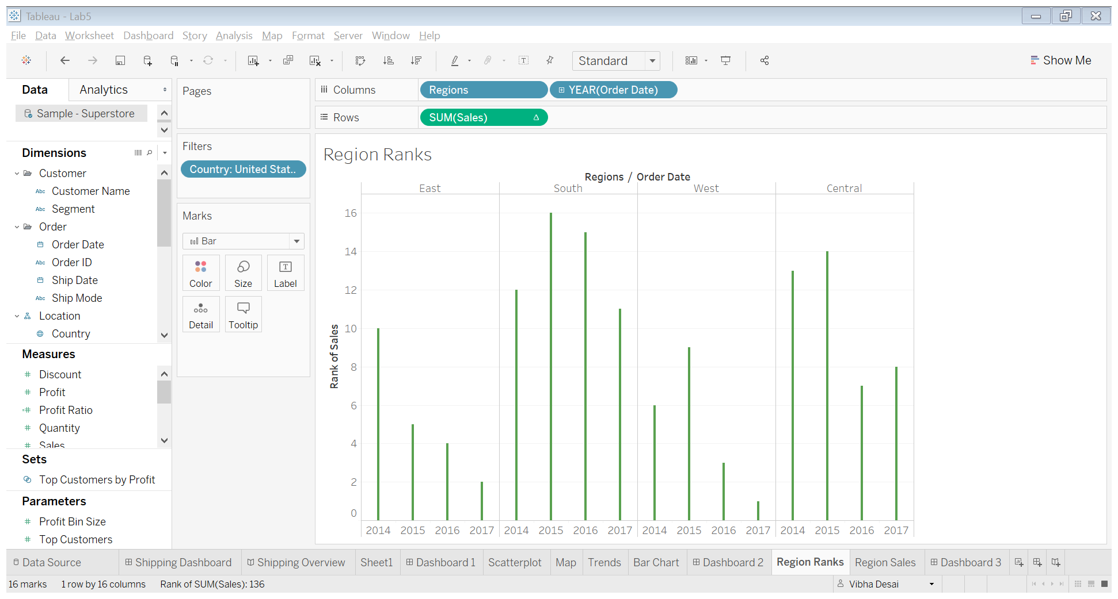

Figure 8: Region Ranks based on Sales

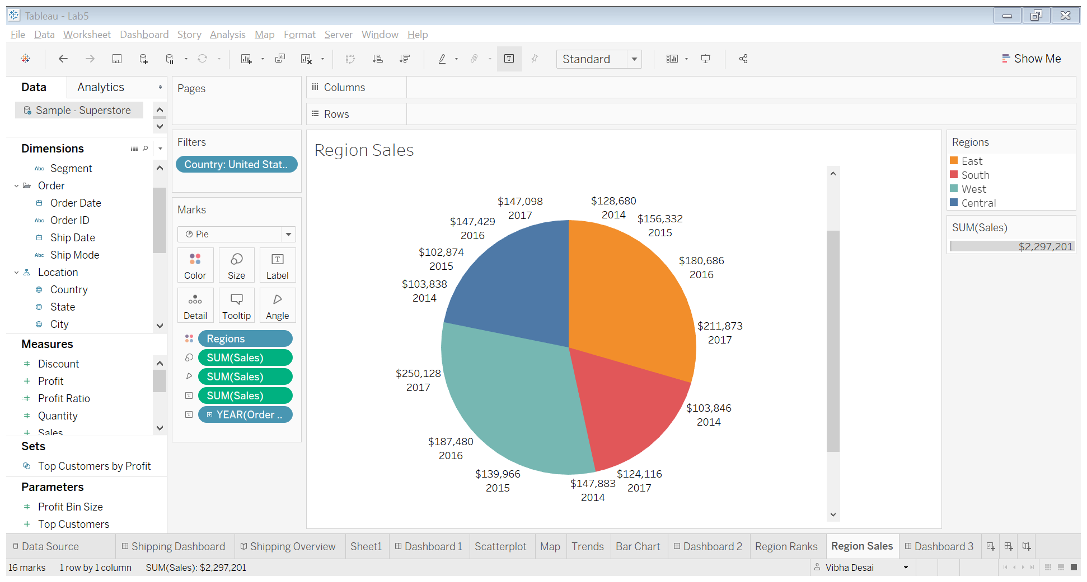

Figure 9: Region Sales

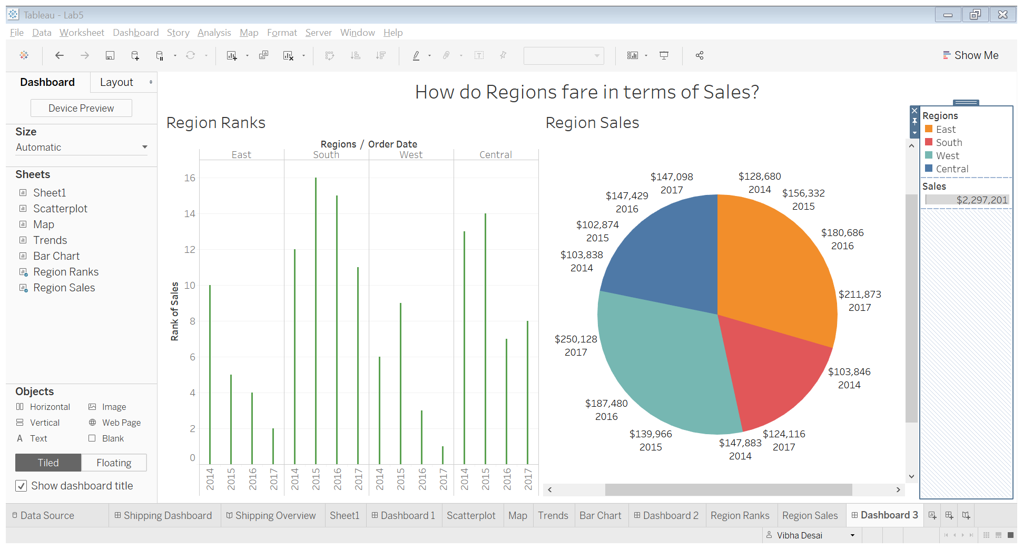

Figure 10: Dashboard on ‘How do Regions fare in terms of Sales?’

Here we had to create a dashboard based on Superstore data. I chose to create two sheets. The first sheet highlights the Ranks of each region based on Sales in the last 4 years. The second sheet is a pie chart highlighting the Sales in each region in past 4 years. This dashboard helps us determine the fall and rise in sales in each region. We can focus on individual region issues and determine the factors to drill down into using this dashboard.